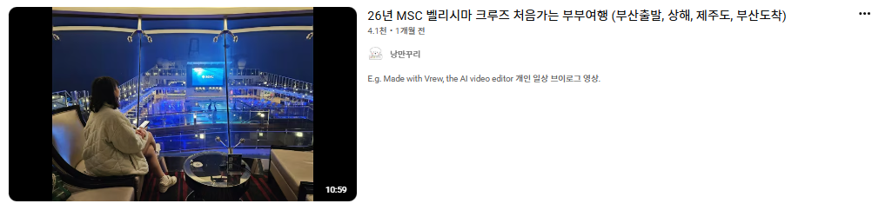

26년 MSC 벨리시마 크루즈 처음가는 부부여행 (부산출발, 상해, 제주도, 부산도착)
4.1천1개월 전

낭만꾸리
E.g. Made with Vrew,

The video titled "26년 MSC 벨리시마 크루즈 처음가는 부부여행 (부산출발, 상해, 제주도, 부산도착)" does not contain a transcript, but here is a summary based on its metadata and available descriptions:
- Departure from Busan: The couple begins their very first cruise trip in 2026 aboard the MSC Bellissima, departing from the port in Busan.
- Onboard Facilities & Room Tour: After boarding the grand cruise ship, they check into their cabin (room 13153) and settle in, providing a brief room and bathroom tour.
- Daily Entertainment & Magic Shows: The cruise offers an array of onboard entertainment, including an interactive magic show that heavily involves audience participation.
- Dining Experiences: They visit the ship's restaurants and 24-hour buffet for various meals, and enjoy a high-quality sushi experience as well.
- Various Activities & Excursions: The video highlights different aspects of cruise life such as evening strolls on the deck, morning yoga, watching live K-pop and theatrical performances, and participating in themed events like a Lego party.
- Stop in Shanghai: The couple wakes up to a rainy day in Shanghai, China, where they step off the ship to explore the city's streets, visit local snack shops, see the iconic skyline, and enjoy a meal before returning to the ship.
- Stop in Jeju: Their next stop is Jeju Island, but they briefly relax at a nearby cafe due to limited planned activities.
- Final Performances & Return: They enjoy more shows onboard, including a circus act and final musical performances, before disembarking in Busan to head back home.

댓글 13개

댓글 추가...


@sanghyunchoi5675
2주 전
부산 영도항이 맞을듯
답글


@nanas111
1개월 전
오! 같은 배를 타고 다녀오셨네요~ 잘 보고 갑니다.!

답글
·
답글 1개


@김수양-m6t
1개월 전
알찬 여행 다녀오셨네요 재미있게 보고갑니다^^

답글
·
답글 1개


@박대원-x3u
1개월 전
설명회때 바로 앞에 있던 사람 입니다. 반갑네요,,

답글
·
답글 1개


@bkbk1461
1개월 전
어디서 예약하셨나요

답글
·
답글 1개


@아름드리-w8r
1개월 전
발코니 객실 비용은 어느정도인지요?

답글
답글 1개


@스매싱한방
1개월 전
부페수준이 궁금해요?

답글
·
답글 1개

